Creating a database and table named Northwind_Database and Products respectively.

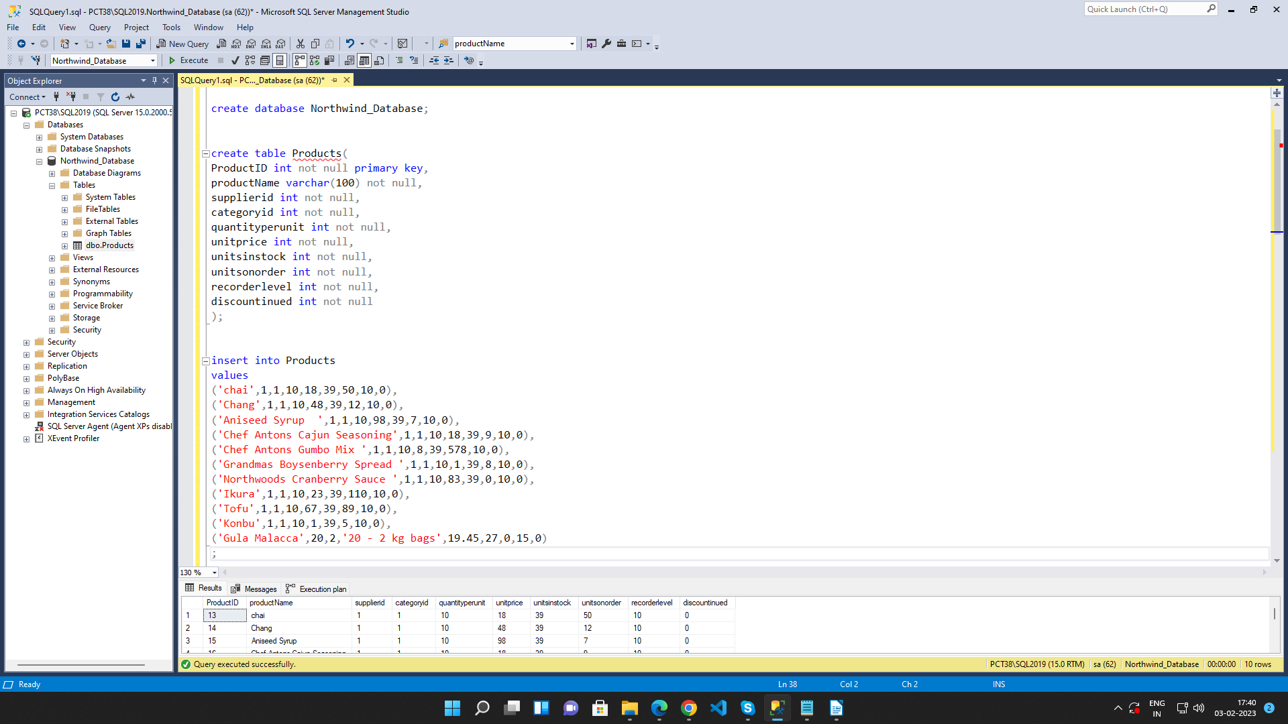

Query 1: Write a query to get a Product list (id, name, unit price) where current products cost
less than $20.
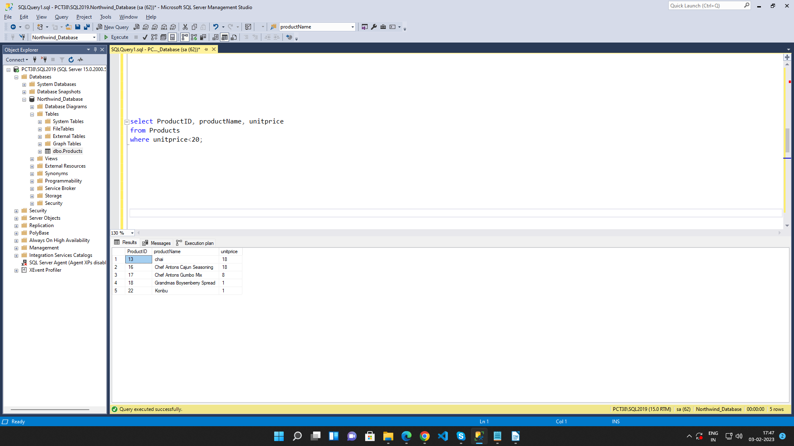

Query 2: Write a query to get Product list (id, name, unit price) where products cost between
$15 and $25.

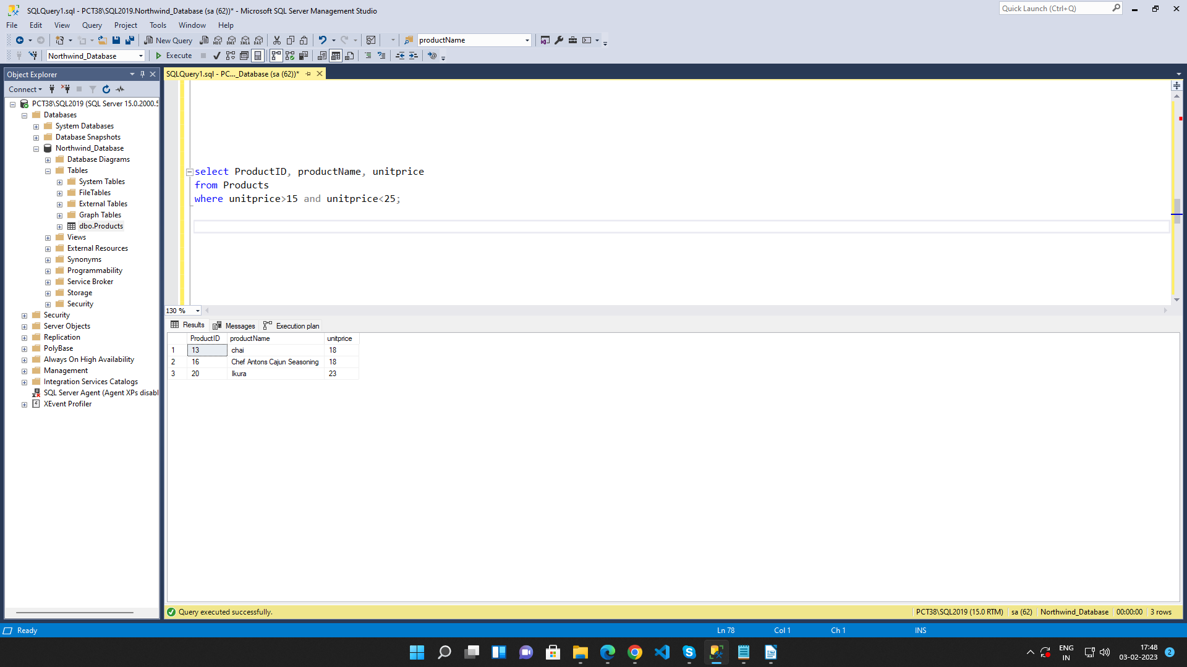

Query 3: Write a query to get Product list (name, unit price) of above average price.

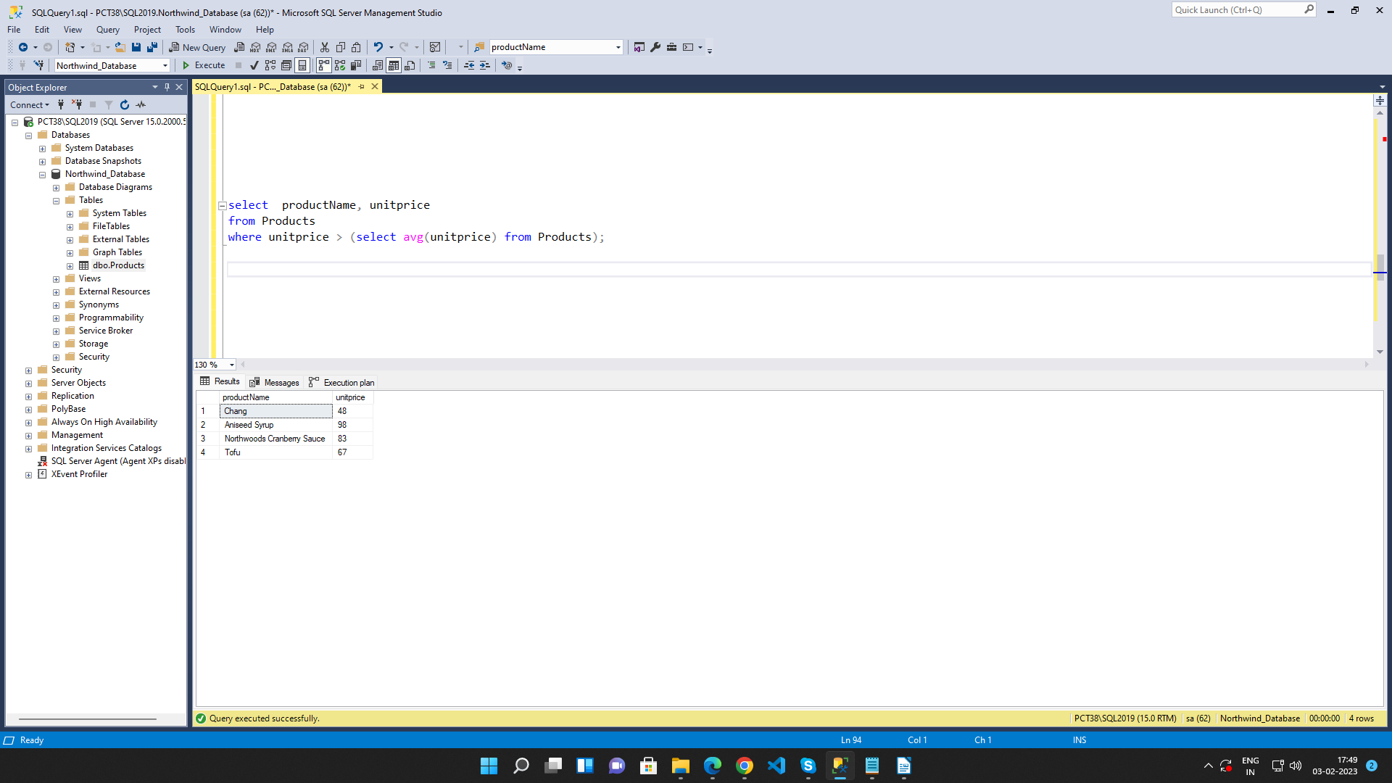

Query 4: Write a query to get Product list (name, unit price) of ten most expensive products
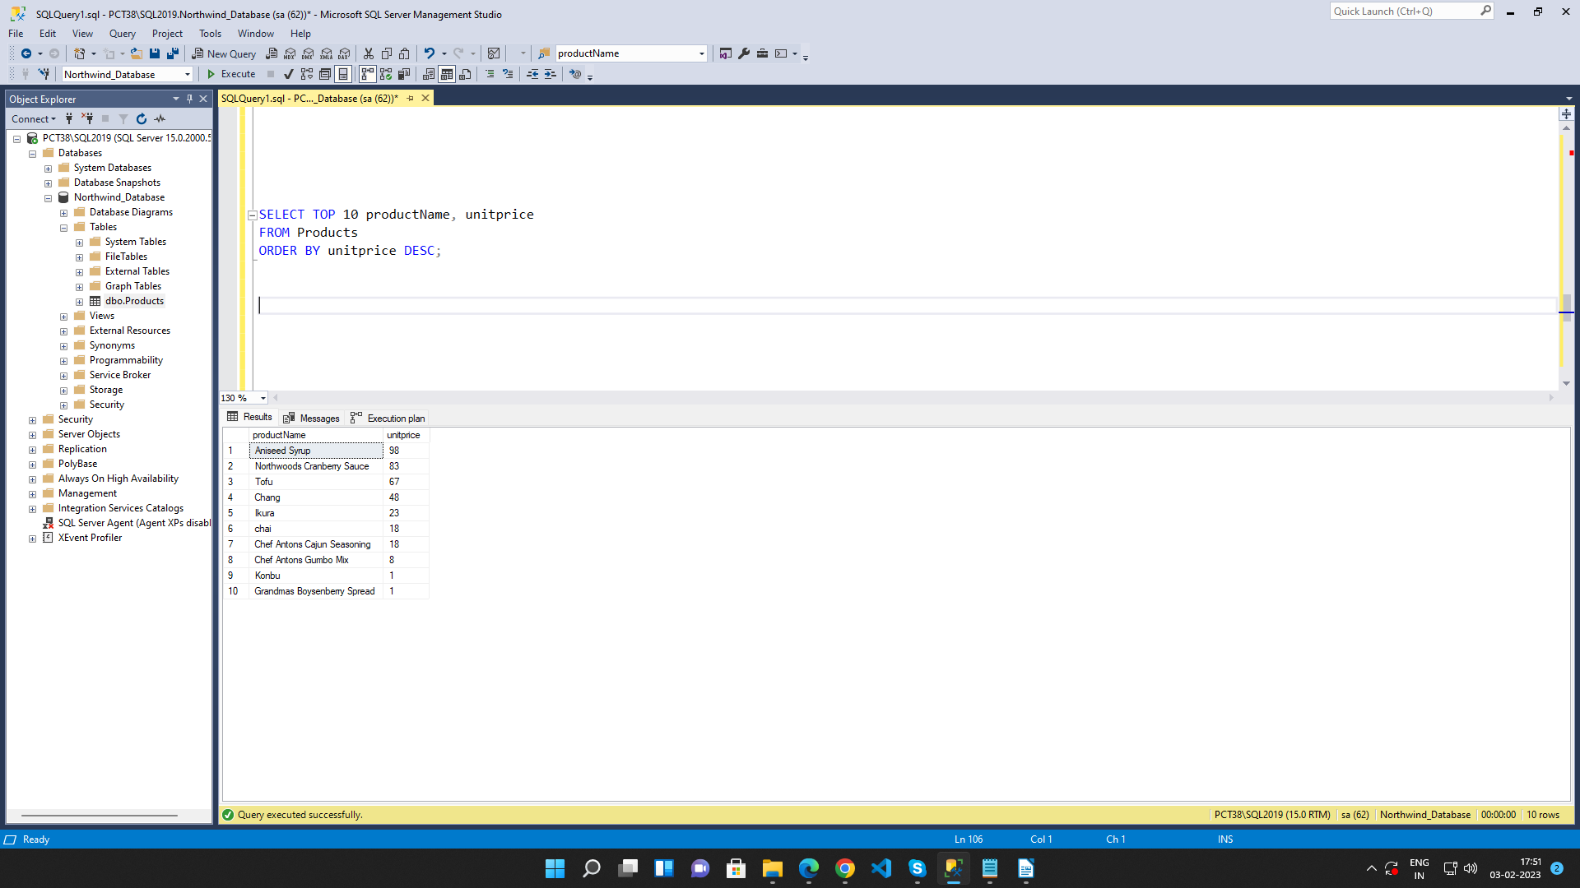

Query 5: Write a query to count current and discontinued products
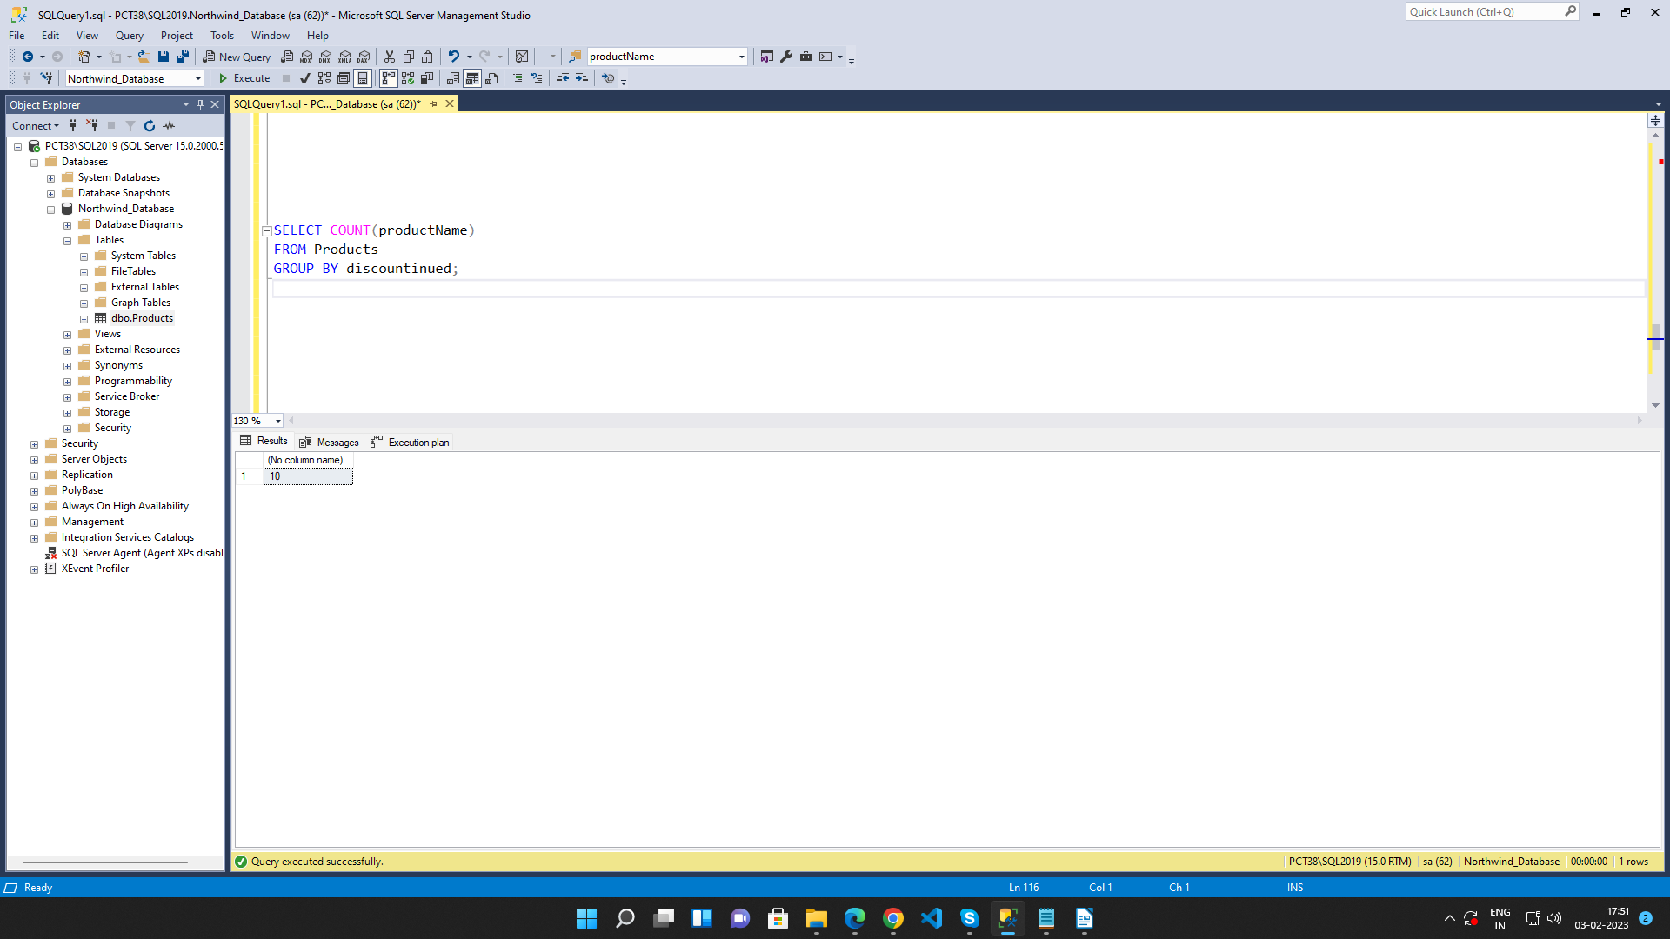

Query 6: Write a query to get Product list (name, units on order , units in stock) of stock is less
than the quantity on order

